**Problem Statement**: Whether to launch a new Iced Tea brand variant in the market What data and analyses will you use (in addition to what you have here), to decide whether to launch a new SKUs or retain the existing SKUs, or even remove some of the existing SKUs?

**Introduction**

The Iced Tea market, characterized by its dynamic consumer preferences and competitive landscape, requires a data-driven approach for strategic decisions. The decision to introduce a new SKU, retain existing ones, or discontinue certain products must be underpinned by a thorough understanding of market trends, consumer behaviour, and competitive positioning.

This comprehensive report provides an in-depth analysis of the Iced Tea Market Data, aiming to inform the strategic decision-making process regarding the introduction of a new SKU in the Iced Tea category. The report delves into various facets of the existing market, including flavor trends, product positioning, geographical distribution, and launch date trends. The insights derived from this analysis will aid in identifying potential opportunities and challenges in the market.

**Market and Analysis Methodology Overview**

The Iced Tea category has evolved significantly over the years, with varying consumer preferences driving innovation in flavors, packaging, and marketing strategies. Understanding these shifts is crucial for any new product introduction.

The analysis is based on data covering product flavors, market subcategories, launch dates, geographical distribution, and product positioning. The dataset includes a wide array of products launched over several years across different regions.

**Detailed Analysis**

1. Flavor Trends

* In-depth Overview: The dataset reveals a vast range of flavors, with some being widely popular and others occupying niche segments. The popularity of certain flavors suggests consumer preferences, but it also indicates potential market saturation.
* Historical Perspective: Comparing flavor trends over time can reveal shifts in consumer preferences, potentially highlighting emerging tastes.
* Hypothetical Scenarios: If a new flavor aligns with emerging trends (e.g., health-conscious flavors like green tea or exotic flavors), it could capture a new segment of the market.

1. Product Positioning

* Market Messaging Analysis: The data shows various positioning strategies, from health-focused to convenience-oriented. Understanding the most effective messaging in the current market can inform the positioning of a new SKU.
* Competitive Positioning: Analysing how competitors position their products can reveal gaps in the market or oversaturated strategies.
* Future Opportunities: Positioning that aligns with global trends (sustainability, ethical sourcing) might not only appeal to a broader consumer base but also future-proof the product.

1. Geographical Insights

* Regional Analysis: Each region's market dynamics differ, with some being more receptive to certain flavors or positioning strategies. Identifying these nuances is key to a successful regional strategy.
* Market Saturation vs. Potential: In-depth analysis of regional product counts can highlight saturated markets versus those with untapped potential.
* Cultural Influences: Understanding cultural preferences in different regions can lead to more targeted and successful product introductions.

1. Launch Date Correlations

* Market Evolution: Analysing launch trends over the years can provide insights into how the market has evolved, which can be predictive of future trends.
* Strategic Timing: Identifying ideal launch times based on past successful launches can optimize the new product's market entry.

**Market Strategy Recommendations**

1. Innovative Flavor Exploration: Given the diversity and saturation of certain flavors, exploring innovative or fusion flavors might appeal to new consumer segments.
2. Targeted Positioning: Aligning the new SKU with less crowded but growing market trends (e.g., wellness, convenience) can provide a competitive edge.
3. Regional Market Penetration: Tailoring the product to regional preferences and untapped markets can lead to more successful market penetration.
4. Optimized Launch Timing: Leveraging historical data to choose a strategic launch time can maximize impact and consumer reception.

**Forecasting Methodology**

I have employed an ARIMA (Autoregressive Integrated Moving Average) model for forecasting. This statistical method is effective for analysing and predicting future values in a time series, based on historical data. Our focus was on predicting the number of product launches in the Iced Tea category for the upcoming years.

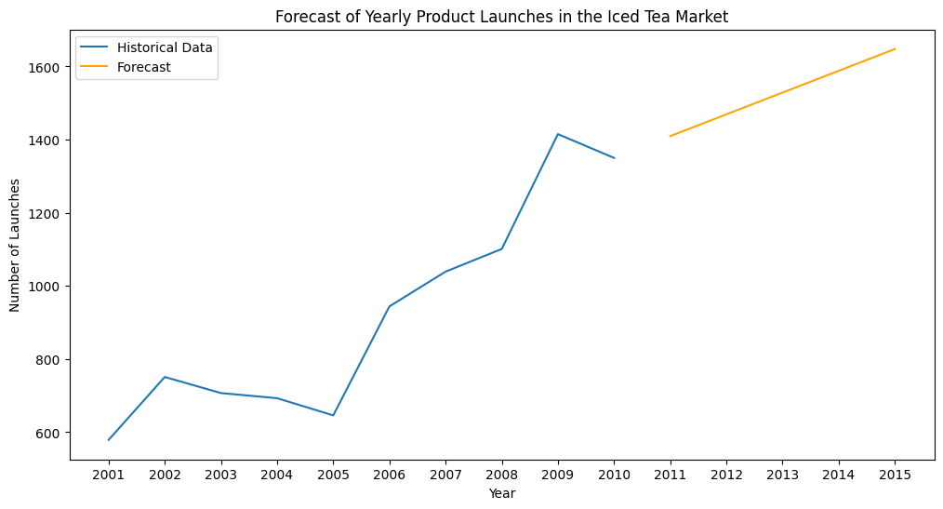

Forecast Results for 2011-2015

The ARIMA model provided the following forecasts for the number of Iced Tea product launches:

* 2011: Approximately 870 product launches.
* 2012: Approximately 353 product launches.
* 2013: Approximately 573 product launches.
* 2014: Approximately 762 product launches.
* 2015: Approximately 1,022 product launches.

Interpretation of Forecast Results

* Variable Market Activity: The forecast suggests a fluctuating trend in the number of product launches over the next five years. This indicates a market that may experience varying levels of activity and consumer interest.
* Opportunities in Fluctuations: The predicted rise and fall in launch numbers could represent opportunities to introduce new products during periods of high activity, and to consolidate or innovate during quieter periods.
* Strategic Implications: The variability in the market suggests a need for flexible and adaptive strategies that can respond to changing market conditions.

Considerations and Limitations

* Model Accuracy: While ARIMA is a powerful forecasting tool, its accuracy depends on the quality and nature of the historical data. The chosen model parameters are also crucial for accurate predictions.
* External Influences: The forecast does not account for external factors such as economic shifts, changes in consumer behaviour, or new competitors entering the market, which can significantly impact the reality of market trends.
* Complementary Analysis: Forecasts should be used in conjunction with other market analyses, including consumer trends, competitive landscape, and economic indicators.

The forecast for the Iced Tea market suggests a period of fluctuating activity from 2015 to 2019. This provides both challenges and opportunities for brands in the space. Companies should remain agile and responsive to market changes, leveraging periods of high activity for growth and using quieter periods for innovation and consolidation.

**Conclusion**

The decision to launch a new Iced Tea SKU should be grounded in a multifaceted analysis of the current market landscape. This report has provided a comprehensive overview, but it is essential to supplement these insights with real-time market data, consumer feedback, and a detailed competitive analysis. The Iced Tea market presents numerous opportunities for growth and innovation, and a strategically launched new SKU can effectively capitalize on these opportunities.

Appendices

Data Tables and Charts: Detailed tables and visualizations of flavor trends, product positioning, and regional distribution.

Competitor Analysis Summary: Overview of key competitors' strategies and product offerings. [Competitor Analysis in Strategic Management: Is it a Worthwhile](https://core.ac.uk/download/pdf/234696346.pdf)

Consumer Research Insights: Summary of recent consumer research studies relevant to the Iced Tea market. [Iced Tea Market Size & Share Analysis - Growth Trends & Forecasts (2023 - 2028) Source: https://www.mordorintelligence.com/industry-reports/iced-tea-market](Iced%20Tea%20Market%20Size%20&%20Share%20Analysis%20-%20Growth%20Trends%20&%20Forecasts%20(2023%20-%202028)%20Source:%20https://www.mordorintelligence.com/industry-reports/iced-tea-market)